PRESS RELEASE
For Immediate Release

SupportYourApp Wins the 2024 Excellence in Customer Service Award
April 10th, Kyiv, Ukraine
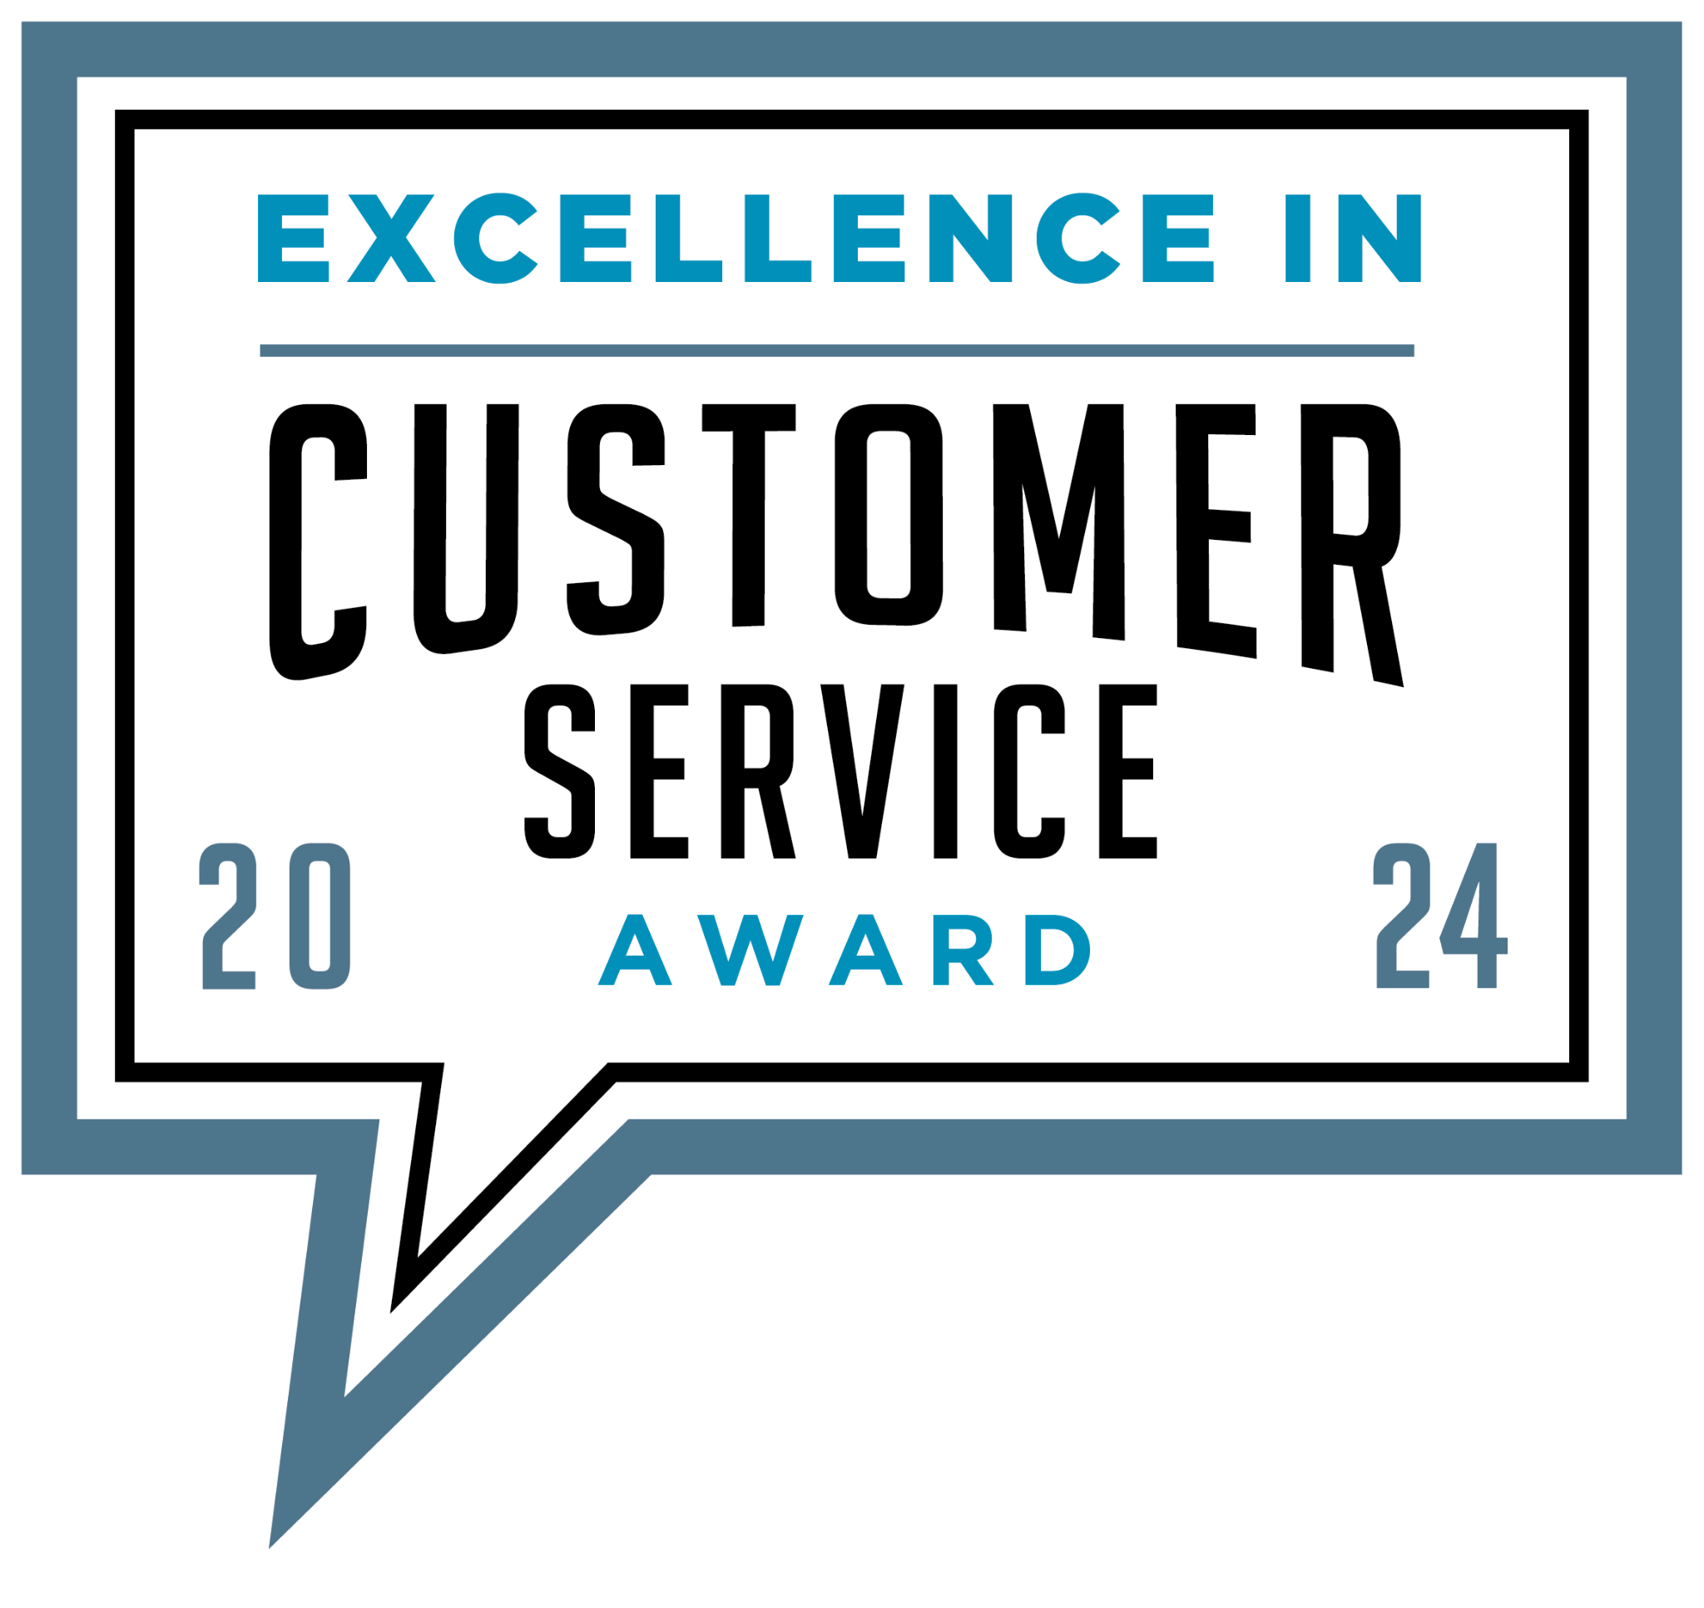
SupportYourApp today announced it has been named a winner in the 2024 Excellence in Customer Service Award presented by Business Intelligence Group.

The Excellence in Customer Service Awards celebrate those who are winning by supporting customers and those who are developing the tools to help others find success. Awards were given out to consultants, outsource partners and technology providers for superior performances in the past 12 months.

SupportYourApp, established in 2010, provides secure outsourced support services to tech businesses worldwide. With 5 offices and 7 hubs globally, the company's team of over 1400 professionals offers a comprehensive range of services such as technical and customer support, back-office assistance, system setup and integration, content moderation, KYC and ID verification, among others. By leveraging their outsourcing solutions, SupportYourApp empowers businesses to focus on their growth and development. Noteworthy is the company's compliance with PCI DSS, HIPAA, and GDPR standards, along with its ISO/IEC 27001:2013 certification, ensuring a high level of security and quality in their services.

“We are thrilled to have been awarded the prestigious title of Outsource Partner of the Year.” said Daria Leshchenko, the CEO and Managing Partner of SupportYourApp. “This recognition reflects our team's dedication to excellence and our commitment to delivering exceptional outsourced support services globally”.

"In today's digital world, exceptional customer service is no longer a differentiator, it's a necessity. A recent study found that 67% of customers recommend products or services to others after a great customer experience, highlighting the measurable impact of prioritizing customer satisfaction," said Maria Jimenez, chief nominations officer of the Business Intelligence Group. "We're thrilled to recognize the 2024 Excellence in Customer Service Award winners who are setting the standard for building trust and loyalty with their customers."

This year’s winners include Mastercard, Pfizer, Inc., Verizon Connect, Freshworks Inc, Samsung Electronics of America and others. The full list can be found here.

###

About Business Intelligence Group
The Business Intelligence Group was founded with the mission of recognizing true talent and superior performance in the business world. Unlike other industry award programs, these programs are judged by business executives having experience and knowledge. The organization’s proprietary and unique scoring system selectively measures performance across multiple business domains and then rewards those companies whose achievements stand above those of their peers.
About SupportYourApp
SupportYourApp is a Support-as-a-Service company that has been providing secure technical, customer support and CX services to growing companies around the globe since 2010 in 60 languages. It is also a software company as much as it is a service company. The company’s team has developed its own AI-powered customer care platform and all-in-one helpdesk solution that boosts support operations. SupportYourApp works with a wide range of tech industries, including SaaS, fintech, platforms, software products, hardware and more.

Contact information:
PR and Partnerships Director,
Viktoriia Cherednyk,
vika@supportyourapp.com

