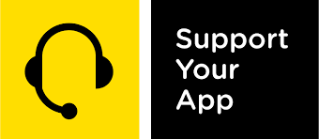
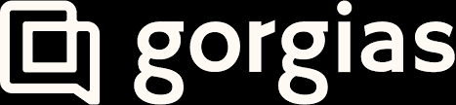

PRESS RELEASE
For Immediate Release

SupportYourApp becomes the Premier Partner of Gorgias

February 13, 2024, Kyiv, Ukraine

Today, SupportYourApp announces it has become the Premier Partner of the Gorgias Partner Program to drive even more value to our clients and elevate our knowledge in the ever-growing e-commerce environment. This program gives us an opportunity to learn, grow and collaborate with like-minded support enthusiasts who want to endlessly improve customer shopping experience.

Gorgias customer service platform is the #1 helpdesk in the e-commerce ecosystem. 14,000+ merchants use Gorgias every day to offer retention-worthy support with AI-fueled customer service solutions.

The Gorgias Partner Program is designed to support Gorgias ecosystem partners in delivering services on top of the Gorgias product and ensuring that mutual customers are successful with the product.

SupportYourApp offers secure outsourced support services to tech businesses worldwide. Founded in 2010, the company has expanded to encompass 5 offices and 7 hubs globally, boasting a team of over 1400 professionals. Their range of services includes technical and customer support, back-office assistance, system setup and integration, content moderation, KYC and ID verification, among others. Through their outsourcing solutions, SupportYourApp enables businesses to concentrate on their advancement. Notably, the company is compliant with PCI DSS, HIPAA, and GDPR standards and holds ISO/IEC 27001:2013 certification.

“We’re excited to become the premier partner of Gorgias and to ensure perfect synergy between the leading support tool and our teams of support heroes.” — Nick Riabchenko, SupportYourApp Chief Integrations Officer.

“We’re thrilled to welcome SupportYourApp into our partner ecosystem and confident that SupportYourApp will continue to be a best-in-class delivery partner for our mutual clients” said Michael Potters, Senior Strategic Partnerships Manager and Channel Lead at Gorgias.

To learn more about joining the Gorgias Partner Program, visit the website.

###

About SupportYourApp
SupportYourApp is a Support-as-a-Service company that has been providing secure technical, customer support and CX services to growing companies around the globe since 2010 in 60 languages. It is also a software company as much as it is a service company. The company’s team has developed its own AI-powered customer care platform and all-in-one helpdesk solution that boosts support operations. SupportYourApp works with a wide range of tech industries, including SaaS, fintech, platforms, software products, hardware and more.

About Gorgias
Gorgias is a one-of-a-kind customer service platform specifically designed for e-commerce businesses to deliver effortless customer service at every stage of growth. With cutting-edge automation and AI capabilities, Gorgias revolutionizes how online stores interact with their customers by providing efficient and personalized support across email, voice, SMS, live chat, and social media channels.

PR Contact
Viktoriia Cherednyk
PR and Partnerships Director
SupportYourApp
vika@supportyourapp.com

