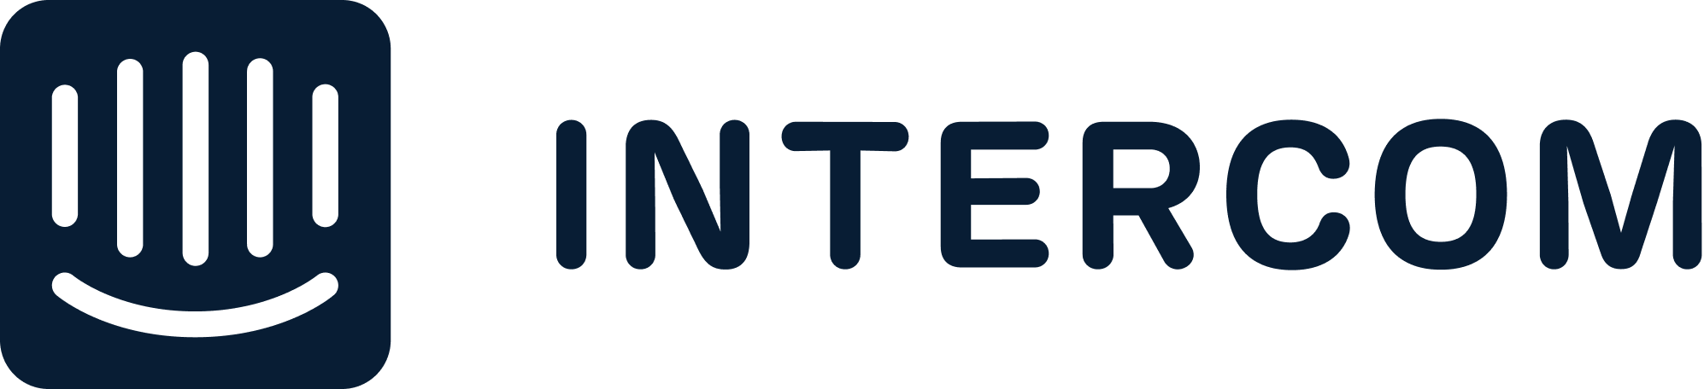

PRESS RELEASE
For Immediate Release

SupportYourApp partners with Intercom to deliver best-in-class customer support services

October 4, 2023, Kyiv, Ukraine

Today, SupportYourApp announces it has joined the Intercom Service Partner Program to deepen their partnership with Intercom and to deliver best-in-class platform implementation and outsourced support services.

Intercom's next-generation customer service platform is built for an AI-first world, combining an AI bot, AI help desk and proactive support tools for businesses to connect directly to their customers. The platform seamlessly integrates with CRMs and many other tools, including Salesforce and Marketo, and features an app store with more than 400 apps and integrations.

The Intercom Service Partner Program aligns digital agencies, consultancies, business process outsourcers (BPOs) and system integrators with the fastest-growing customer service platform to help partners build expertise in Intercom’s offerings. Partners have exclusive access to education resources, pre-sales support, brand marketing perks and tools to help them expand client engagements and recommend the strongest AI customer service platform.

SupportYourApp provides secure and reliable services to global tech businesses. The company was established in 2010 and has since grown to 4 offices in Eastern Europe and 7 hubs around the globe. The SupportYourApp team now consists of over 1200 professionals. The company provides such services as technical and customer support, back-office support, content moderation, KYC and ID verification and many more.
By providing outsourcing solutions, they allow businesses to focus on their growth and development. SupportYourApp is PCI DSS, HIPAA, and GDPR-compliant and ISO/IEC 27001:2013 certified.

“Our support teams have been using Intercom for customer communication for years. We are very excited and honored for this next chapter in our collaboration with them. We know — together with Intercom, we can keep on revolutionizing the customer support industry and will continue raising the bar for the customer service quality” — Nick Riabchenko, SupportYourApp Chief Integrations Officer.

“SupportYourApp is the newest service partner to build their Intercom expertise and develop an Intercom strategy that will not only deepen client relationships, but also align them with the industry leader in delivering faster, higher quality and more comprehensive customer service to their customers,” said Catherine Brodigan, Global Head of Partnerships at Intercom. “Together, SupportYourApp and Intercom will help businesses retain customers and grow faster.”

To learn more about joining the Intercom Service Partner Program, visit the website.

About SupportYourApp
SupportYourApp is an international Support-as-a-Service company that provides secure customer and technical support services with a focus on the tech industry, including SaaS, fintech, apps, platforms, software products, hardware for over 250 clients from all over the world. SupportYourApp is also a software company that has developed its own refined CRM system, a live chat tool, chatbot builders, cloud-based telephony and AI-powered productivity tools.

About Intercom
Intercom is the next generation customer service platform, built for an AI-first world. It is the only solution that combines an AI bot, AI help desk and proactive support tools into one seamless platform. Customer service teams from more than 25,000 global organizations, including Atlassian, Amazon and Microsoft, use Intercom to send over 600 million messages per month and enable interactions with over 800 million monthly active end users. The company was founded in 2011 and is backed by leading venture capitalists, including Bessemer Venture Partners, Kleiner Perkins and Social Capital.

PR Contact
Viktoriia Cherednyk
SupportYourApp
vika@supportyourapp.com

